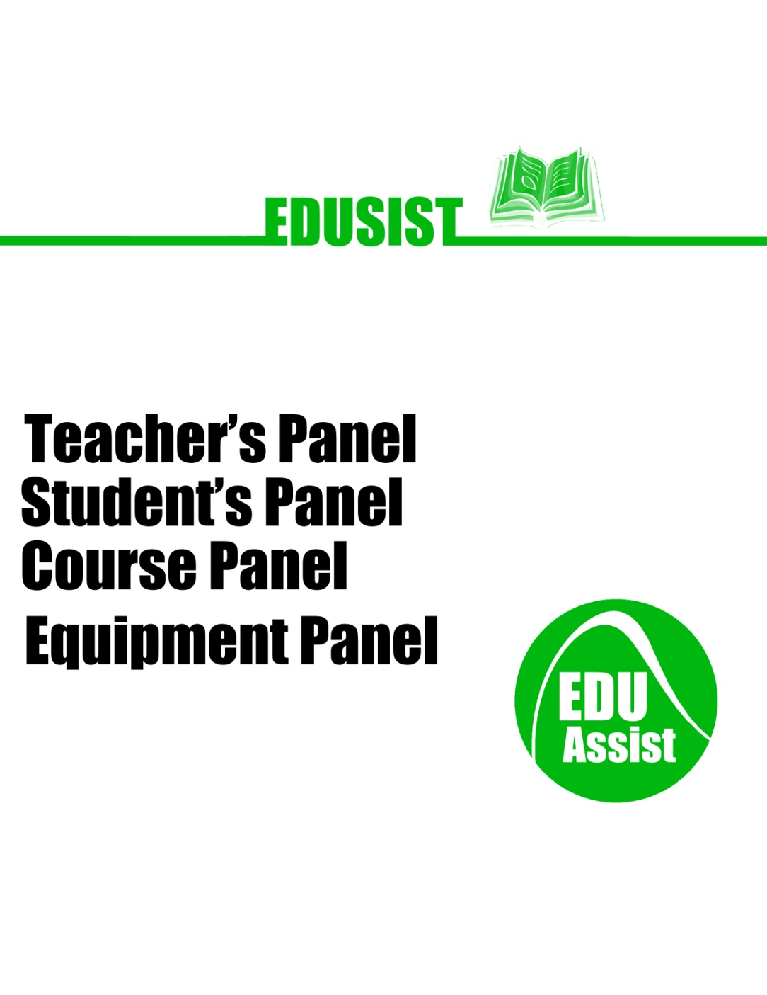Project Name: EDUSIST

Project Members: Shayan G, Amil S. Ramie R, Moeen M.

Date: 2012-01-23

Course: ICS4U

**User Manual**

|  |  |
| --- | --- |
| Introduction | Section 1 |
| Program Description | Section 2 |
| Using the program | Section 3 |

1. **Introduction**

EDUASIST was made for any YRDSB secondary school that requires the need for a tool that will help teachers and students organize and manage their courses. Easy to use, this program can be used by anyone upon reading this simple manual.

1. **Program Description**

There are multiple forms in the Edusist program. They are designated for specific staff members in the school. The program will start off with the main Eduasist login form where a student, teacher or principal will be able to login. Depending on the role chosen by the user, different options will appear designated for the user. Please read Section 3 to learn how to use the program for a student, teacher or principal.

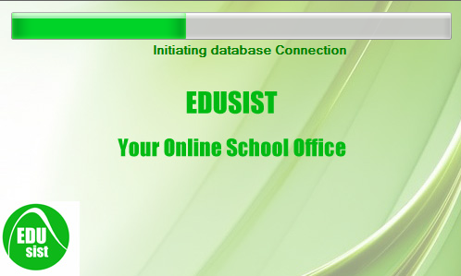

(Programming loading)

1. **Using the program**

Student Role:

1. Begin by selecting the student role and entering your username and password and login.

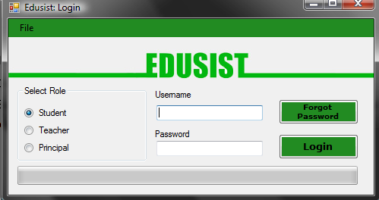

1. From the student profile panel, you will be able to access the courses you are taking, your current marks and you will be able to contact your teacher. You can also change your password if you have forgotten it.

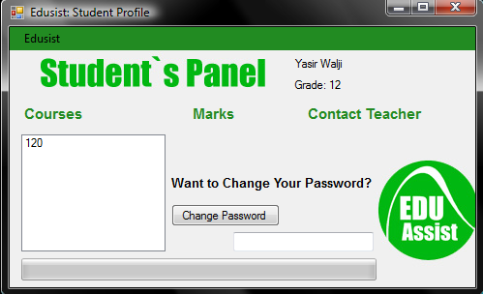

Teacher Role:

1. Begin by selecting the Teacher role and entering your username and password and login. From the teacher profile panel, you will be able to access the courses you are teaching. You can view your student’s information and you will be able to go to you email.com

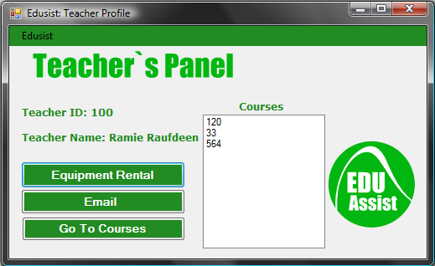

Principal Role:

1. Begin by selecting the Principle role and entering your username and password and login. From the principle profile panel, you will be able to create the courses, students, teachers and equipment objects for the school.

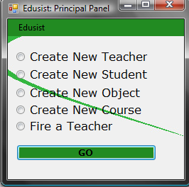

Using the Principle forms:

The above are all accessible for the principal to create. All information asked for is required when trying to create a new teacher, student, object, course or firing a teacher. *Note*: Creating a new course requires the sum of Application, Communication, T/I, K/U, Exam, and Culminating to equal 100. Through these forms, the principal can set up the school system.